**Activity based**

**Project Report on**

**Artificial Intelligence**

**Lab CIE**

**Submitted to Vishwakarma University, Pune**

**Under the Initiative of**

**By**

**Imaad Imran Hajwane**

**SRN No: 202101132**

**Roll No: 23**

**Div: A**

**Third Year Engineering**

**Department of Computer Engineering**

**Faculty of Science and Technology**

**Academic Year**

**2023-2024 Term-II**

**Problem Statement:**

Generate Lexical and Semantic analyser for Protocol Specification Language using Flex and Bison

CODE:

Lexical:

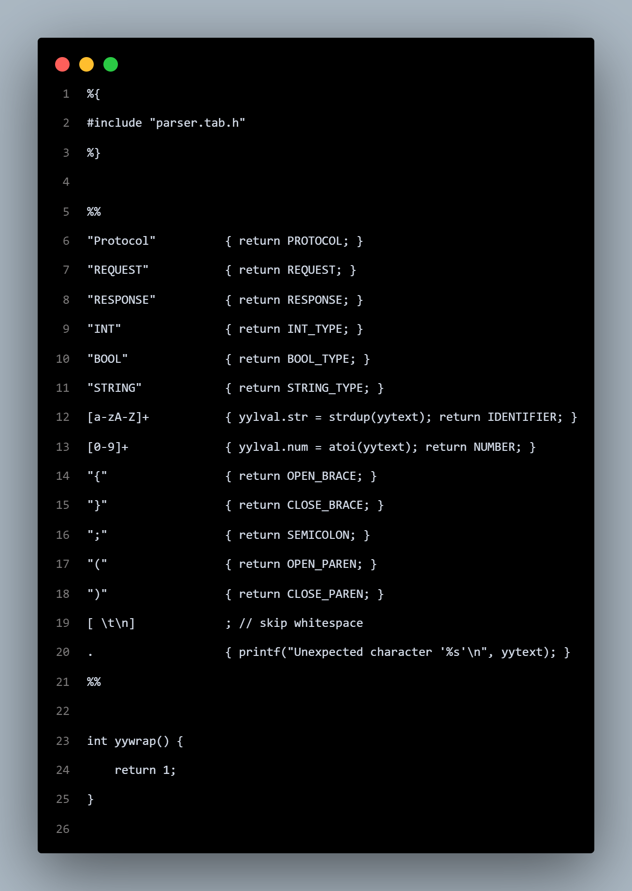

Semantic:

%{

#include <stdio.h>

#include <stdlib.h>

#include <string.h>

extern int yylex();

extern FILE* yyin;

void yyerror(const char* msg) {

// Do nothing for syntax errors

}

%}

%union {

int num;

char* str;

}

%token <num> NUMBER

%token <str> IDENTIFIER

%token PROTOCOL REQUEST RESPONSE INT_TYPE BOOL_TYPE STRING_TYPE OPEN_BRACE CLOSE_BRACE SEMICOLON OPEN_PAREN CLOSE_PAREN

%%

Protocol : PROTOCOL IDENTIFIER OPEN_BRACE ProtocolBody CLOSE_BRACE;

ProtocolBody : RequestResponseList;

RequestResponseList : RequestResponse | RequestResponseList RequestResponse;

RequestResponse : Request | Response;

Request : REQUEST IDENTIFIER OPEN_BRACE RequestBody CLOSE_BRACE SEMICOLON;

RequestBody : INT_TYPE IDENTIFIER SEMICOLON STRING_TYPE IDENTIFIER SEMICOLON;

Response : RESPONSE IDENTIFIER OPEN_BRACE ResponseBody CLOSE_BRACE SEMICOLON;

ResponseBody : BOOL_TYPE IDENTIFIER SEMICOLON STRING_TYPE IDENTIFIER SEMICOLON;

%%

int main(int argc, char** argv) {

if (argc < 2) {

fprintf(stderr, "Usage: %s input_file\n", argv[0]);

return 1;

}

FILE* input = fopen(argv[1], "r");

if (!input) {

perror("fopen");

return 1;

}

yyin = input;

yyparse();

fclose(input);

printf("Lexical and Semantic Analysis completed, Result.txt file formed!");

return 0;

}

Input:

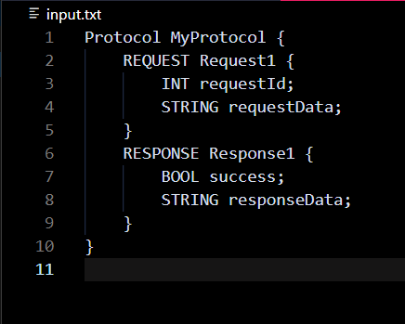

Output:

